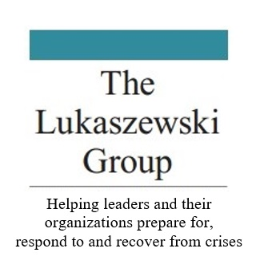 | Crisis Proofing Your Organization:  How Your Crisis Plan Can Pass Seven Powerful Reputation Protecting Tests  A webinar sponsored by
Centre for Strategic Communication Excellence

Presented by
James E. Lukaszewski,
ABC, Fellow IABC; APR, Fellow PRSA,
PRSA BEPS Emeritus

 | Tuesday, June 9th 2020

Contents
- Introduction: James E. Lukaszewski.…………………....……………2
- James E. Lukaszewski – Personal Profile…………………………….3
- What I Believe……………………………………………………………………4
- The Ethical and Practical Principles That Guide Jim’s Practice
------------------------------------------------------------------------------5
- Ingredients of Leadership – Executive Summary………………..6
- Managing the Victim Dimension of Large-Scale Disasters…..8
- The Perfect Apology………………………………………………………...20
- Winning When Everyone is Mad…………………………………..….21
- Your Quick Guide to Communications/Response Planning
(Including Crisis Response Map)…………………………………..…..24
- The Decency Code: The Leader’s Path to Building Integrity
and Trust…………………………………………………………………………..46

Introduction
James E. Lukaszewski, ABC, Fellow IABC, APR, Fellow PRSA
PRSA BEPS Emeritus
America’s Crisis Guru®

James (Jim) E. Lukaszewski (Loo-ka-SHEV-skee) is one of America’s most visible corporate go-to people for senior executives when there is trouble in the room or on the horizon. As America’s Crisis Guru®, Lukaszewski is known for his ability to help executives look at problems from a variety of sensible, constructive and principled perspectives. He is known for taking a business approach rather than traditional PR strategies by teaching clients to take highly focused, ethically appropriate action.

He believes that all questionable, inappropriate, unethical, immoral, predatory, improper, victim-producing and criminal behaviors are intentional. All ethical, moral, compassionate, decent, civil and lawful behaviors are intentional. The choice is clear and always yours.

Lukaszewski has written 14 books and hundreds of articles and monographs. His newest book, The Decency Code, The Leaders Path to Integrity and Trust was published by McGraw Hill in March 2020.

Jim has been a student of the pathology of management and leadership misbehavior for more than 40 years. He has used this knowledge in real time to guide the recovery of over 300 companies, domestic and international, through over 400 victim producing events. Lukaszewski believes that while every organization experiences a variety of difficulties and challenges as they operate, those that suffer serious adverse circumstances do so as the result of their intentional decisions, acts, and omissions.

He believes and teaches that a workplace with integrity, civility and decency is a safer more ethical workplace. His writings on crisis management, being a trusted strategic advisor and leadership recovery are so extensive that wherever you study Public Relation on the planet you will likely see, hear or view some of Lukaszewski’s ideas.

He has received most of the significant US professional recognitions from public relations organizations and academic institutions. His profile appears in Wikipedia, and more than 20 editions of Who’s Who. Corporate Legal Times once listed him as one of 28 experts to call when “All Hell Breaks Loose.”

His work in Public Relations Ethics began in 1984 when he was appointed to the Board of Ethics and Profession Practice of the Counselors Academy. In 1994 he was appointed the PRSA National Board of Ethics and Professional Standards. In 2016 The PRSA National Board appointed Jim BEPS Emeritus. He remains an active but ex-officio member of BEPS.

Revised 4/27/20 Word Count: 379

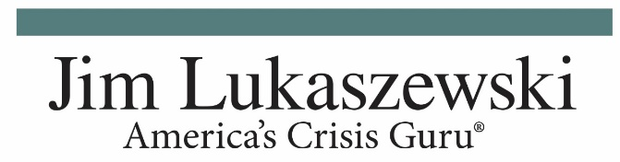
A Personal Profile
Powerful Speaker, Important Author, Inspiring Teacher, Trusted Advisor
Purpose: Through helping resolve the significant troubles of others, find and do what will be the most important things I will ever do in my career and life.
Vision/Aspiration: To be an authentic trusted Communicator, Coach, Counselor and Strategic Thinker; to be the first call when leaders and managers face their toughest, touchiest, most sensitive and devastating situations
Mission: To be the table, truly strategic; promptly finding those exceptionally achievable, ethical, honorable, powerful, and sensible solution options to the most challenging leadership, management and organizational problems.
Disciplines: Trustability; Verbal clarity; Management Perspective/Sensitivity; Findable, Gettable, Doable, Achievable, Knowable approaches; Tomorrow Focused; Thoughtful, Incremental Advice; Intuition-Pattern Sensitivity; Lifelong Learning; Teach, Coach, Counsel to inspire and expand Management and leadership influence and success.
Values/Virtues: Compassion; Constructive Approaches; Curiosity; Honesty; Inconsistency; Positivity; Pragmatism; Promptness; Truthfulness.
Principles: Candor; Communicate Promptly-Intentionally; Destiny Management; Pathologist, Empathy/Compassion/Apology; Engagement; Openness; Responsiveness; Transparency; Truthfulness.
Passion: Help all staff functions (i.e. PR, HR, Law, Security, Strategic planning, etc.) be more important, have more access and influence, be sought after earlier and have happier, more productive successful professional careers.
Curiosity: (Based on an insight from Helio Fred Garcia) Approach leaders and leadership, managers and management, and influential people from the perspectives of an anthropologist/ pathologist, considering the whole person, their motives and their intentions. Question constantly, explore relentlessly.

Jim Lukaszewski
What I Believe

All questionable, inappropriate, unethical, unconscionable, immoral, predatory, improper, victim-producing and criminal behaviors are intentional. All ethical, moral, compassionate, decent, civil and lawful behaviors are also intentional. The choice is always clear and always yours.

Workplaces with integrity, civility, respect and decency are safer and more ethical.

Those who lead with genuine integrity, civility, respect and decency are likely to be more ethical.

Unconscionable intentions, behaviors, actions and decisions, those that vilify, damage, demean, dismiss, diminish, humiliate, caused needless but intentional pain, express anger and irritation, demand or bully, are mean, negative, insulting, disrespectful, disparaging, tone deaf, without empathy, that intentionally injure, accuse, over bear, are punitive, harmfully restrictive, exceed the boundaries of decency civility and integrity, all are unethical.

Apology is the atomic energy of empathy. Apologies tend to stop bad things from starting and starting bad things to stop.

Empathy is positive, constructive actions and deeds that demonstrate civility, decency and integrity while speaking louder than words possibly can.

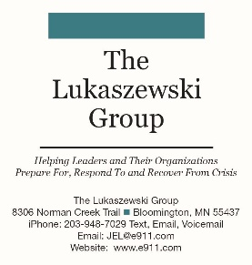
The Ethical and Practical Principles That Guide Jim’s Practice

James E. Lukaszewski
ABC, Fellow IABC, APR, Fellow PRSA, BEPS Emeritus
- Act ethically, promptly and urgently.
- Ask better questions than anyone else.
- Be 15 minutes early.
- Consistently challenge the standard assumptions and practices of our profession, build its importance and enhance the ability of all practitioners to better serve others from their perspective. Raise your hand.
- Do the doable; know the knowable; get the getable; arrange the arrangeable.
- Expect to be helpful and useful.
- Focus on what really matters. Apply your ethics audit analysis.
- Go beyond what those you work with already know or believe.
- Intend to make a constructive ethical difference every day.
- Intentionally look at every situation and circumstance from different perspectives.
- Look out for the real victims.
- Remember, it’s your boss’s “bus.” They get to drive it wherever they want. If you don’t like it, or can’t deal with it, hop off and go to somebody else’s bus, or drive your own.
- Remember that every issue, question, concern or problem is a management issue, question, concern or problem before it is any other kind of issue, question, concern or problem.
- Start where leadership or management is or you will arrive at different destinations.
- Strive for positive, sensible, simple, honorable and ethical solutions.
- The golden rule of sharing ideas: If the boss won’t do your suggestion in 10 days, they never will. Give it up and suggest something new.
- Understand and leverage advice from pattern recognition.
- Your role on “the bus” is to help the driver drive better.

EXECUTIVE SUMMARY:
THE INGREDIENTS OF LEADERSHIP©

By James E. Lukaszewski, ABC, Fellow IABC, APR, Fellow PRSA, BEPS Emeritus

- BE POSITIVE. Eradicate the use of negative words.
- BE A VERBAL VISIONARY. Use your voice, tell stories, motivate, inspire, be a reminder, be a coach, reduce contention, wage peace.
- BE CONSTRUCTIVE. Eliminate the use of criticism as a means of teaching, coaching or educating. Eliminate criticism and you make friends rather than critics, or worse.
- BE PROMPT. Defeat critics, bloviators and bureaucrats. Reduce cost, reduce the production of victims and angry people, find out what’s going to happen sooner, make better mistakes next week.
- BE OUTCOME FOCUSED. Focus on tomorrow rather than yesterday. Yesterday belongs to everyone according to their own personal perspectives and perceptions. Work to build tomorrow together. Start discussing yesterday and tomorrow never comes.
- BE REFLECTIVE. Seek only useful, positive lessons from the past that can be directly applied to something you intend to achieve tomorrow. The rest is a waste of time.
- BE PRAGMATIC. Start where the truth begins. Get the getable, know the knowable, do the doable, achieve the achievable, find the findable, temper the overly optimistic.
- BE A YES PERSON. Select that which can be done and focus on that.
- BE FOCUSED ON THE CRUCIAL FIVE PERCENT. According to Price Pritchett, change and culture change expert, 95% of what we do doesn’t and never will matter. Focus on the 5% and get to tomorrow faster.
- BE A FINISHER. Start what you can finish, stop what can’t be done, avoid endless, mindless projects. Focus on completion.
- BE RELENTLESS IN SEEKING POSITIVE, INCREMENTAL, PERSONAL IMPROVEMENT EVERY DAY. Ask yourself the five crucial questions of daily progress:

- What do I know now that I didn’t know when the day began?

- What’s the most important thing I learned?

- What’s the most interesting thing I learned?

- What questions arose today that will need answers by tomorrow?

- What will I change tomorrow and do better based on what I learned from today?

Day's End Questions for Leaders
Leaders automatically ask themselves several questions at the end of each day. This is a
discipline that will ensure that even your most frustrating day is rewarding and important for you or someone else:

- What leadership lesson did I learn today?

- How can I apply that learning to something I’m currently working on or something I want others to work on?

- How many times did I effectively repeat, restate, reemphasize and renew a rule, a guideline, an incentive, an instruction, a virtue, value or idea others needed to know?

- What specifically did others learn from me today?

- How many times today did someone tell me they heard me quoted in a meeting they
attended and people were inspired to move ahead?

- How or what have I improved in some way for someone else today?
Leadership is the strategic positive force that drives individuals, organizations, cultures, and societies forward every day. Leadership is the discipline of being intentionally constructive with a relentlessly positive approach to helping everyone. It's about having and helping others have an important, happy, influential, constructive and successful life.
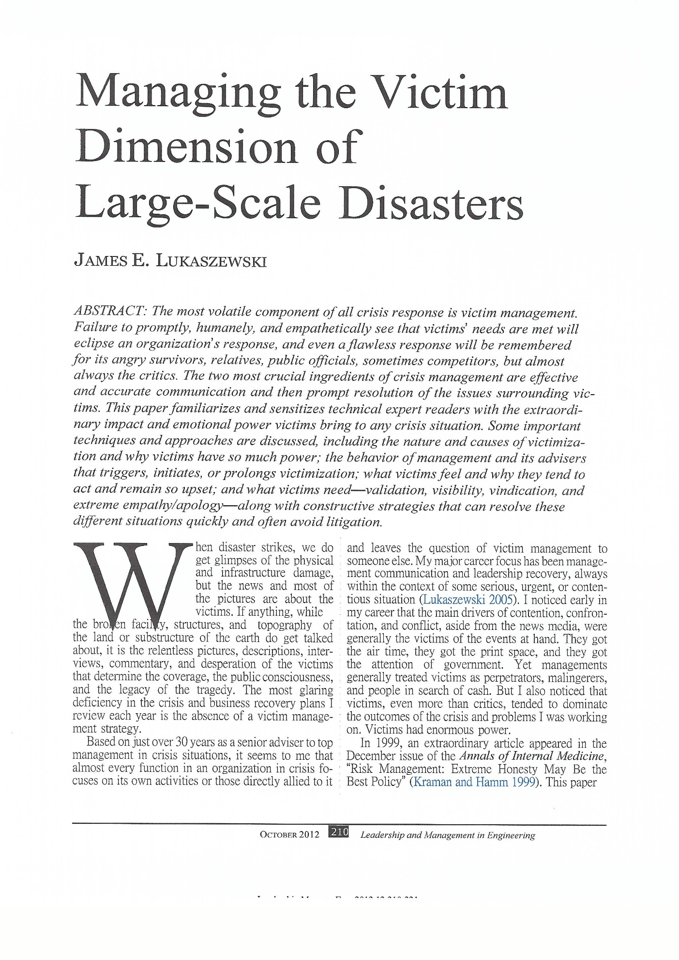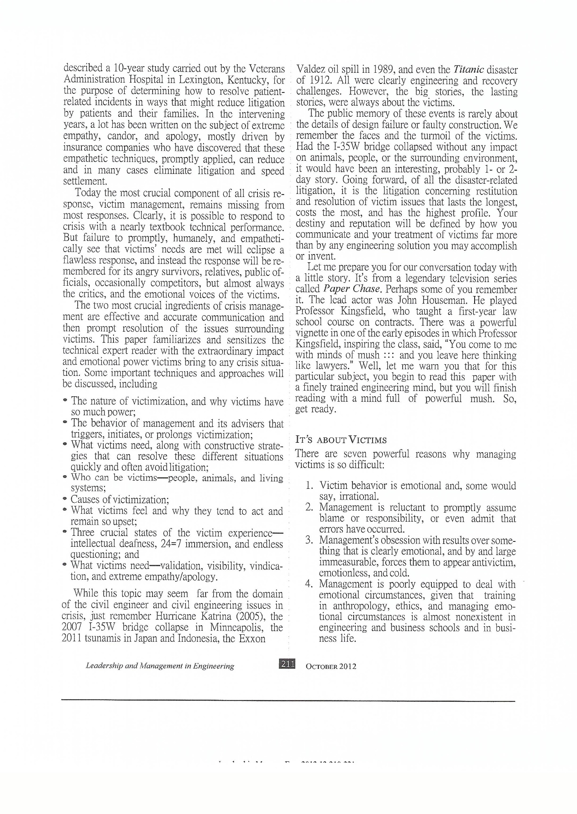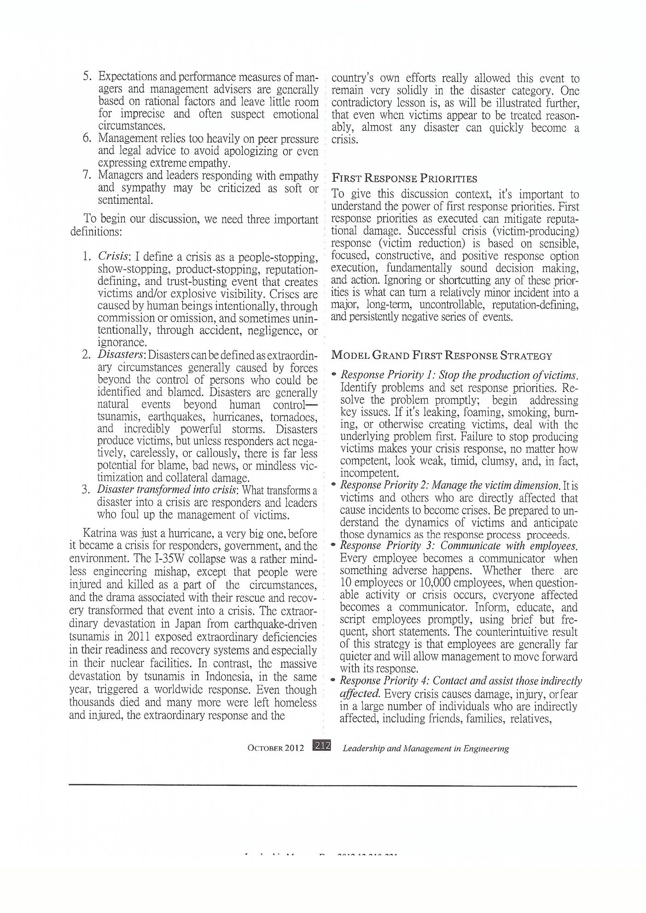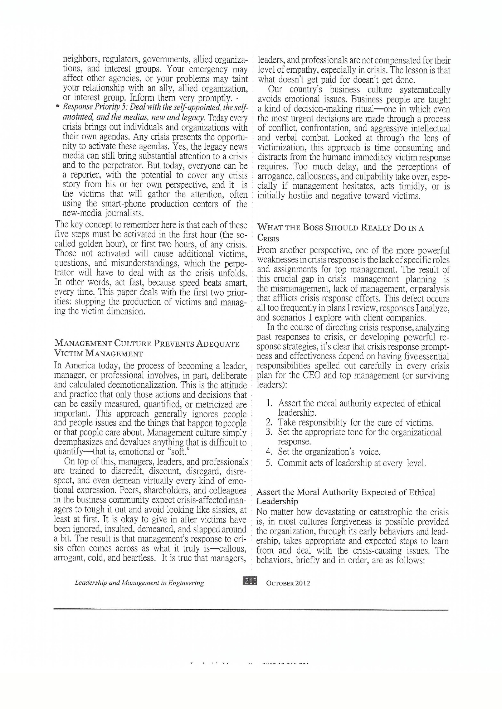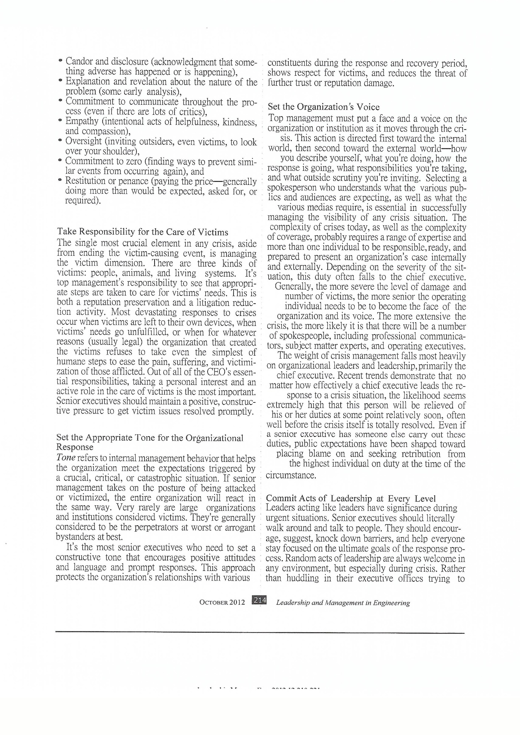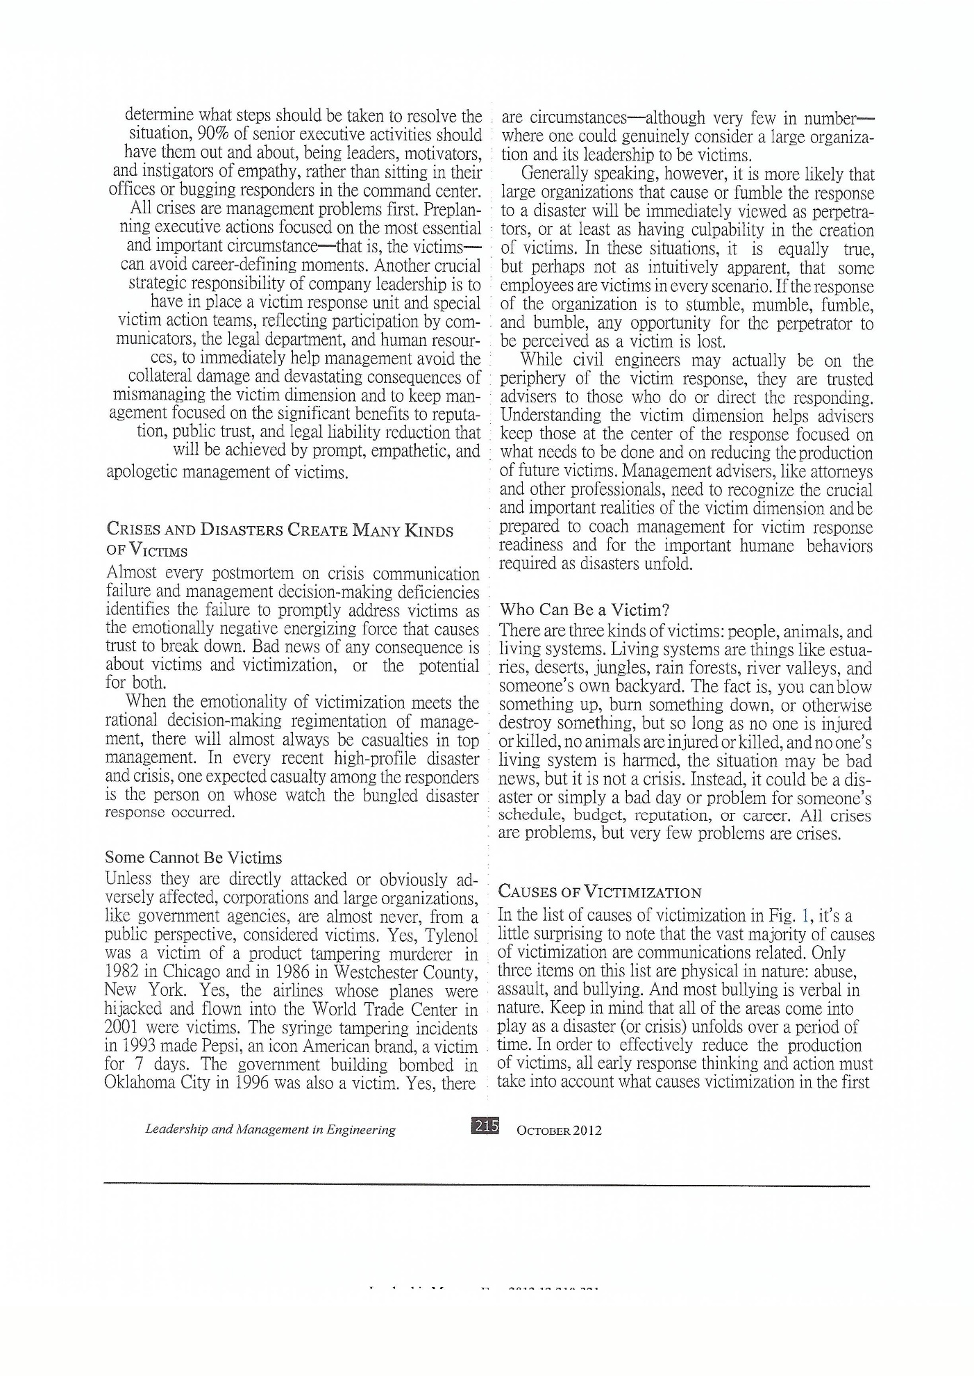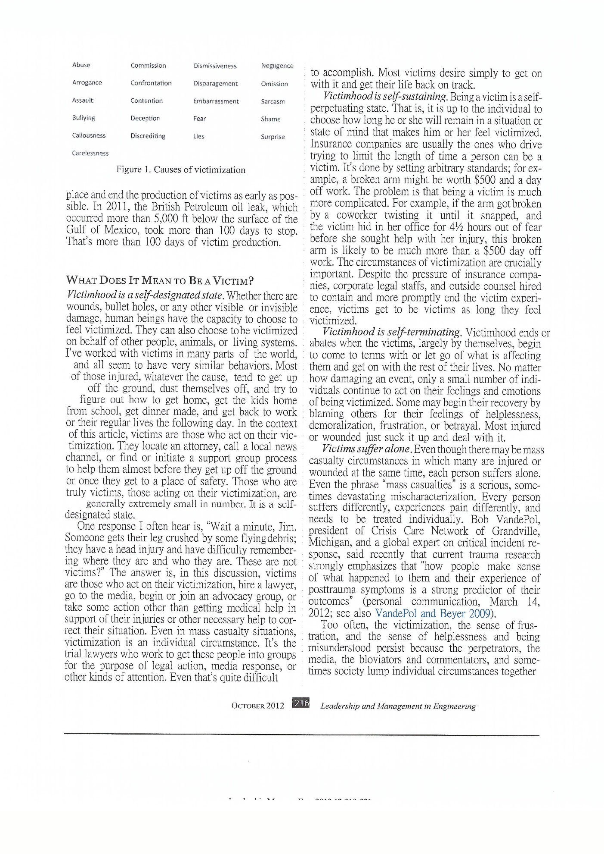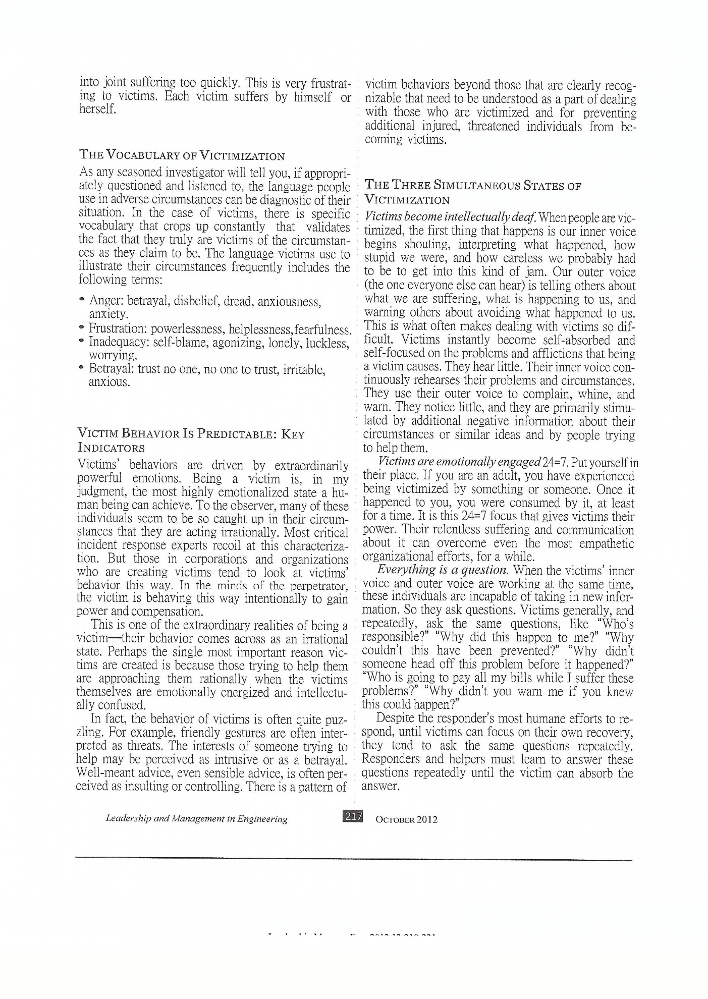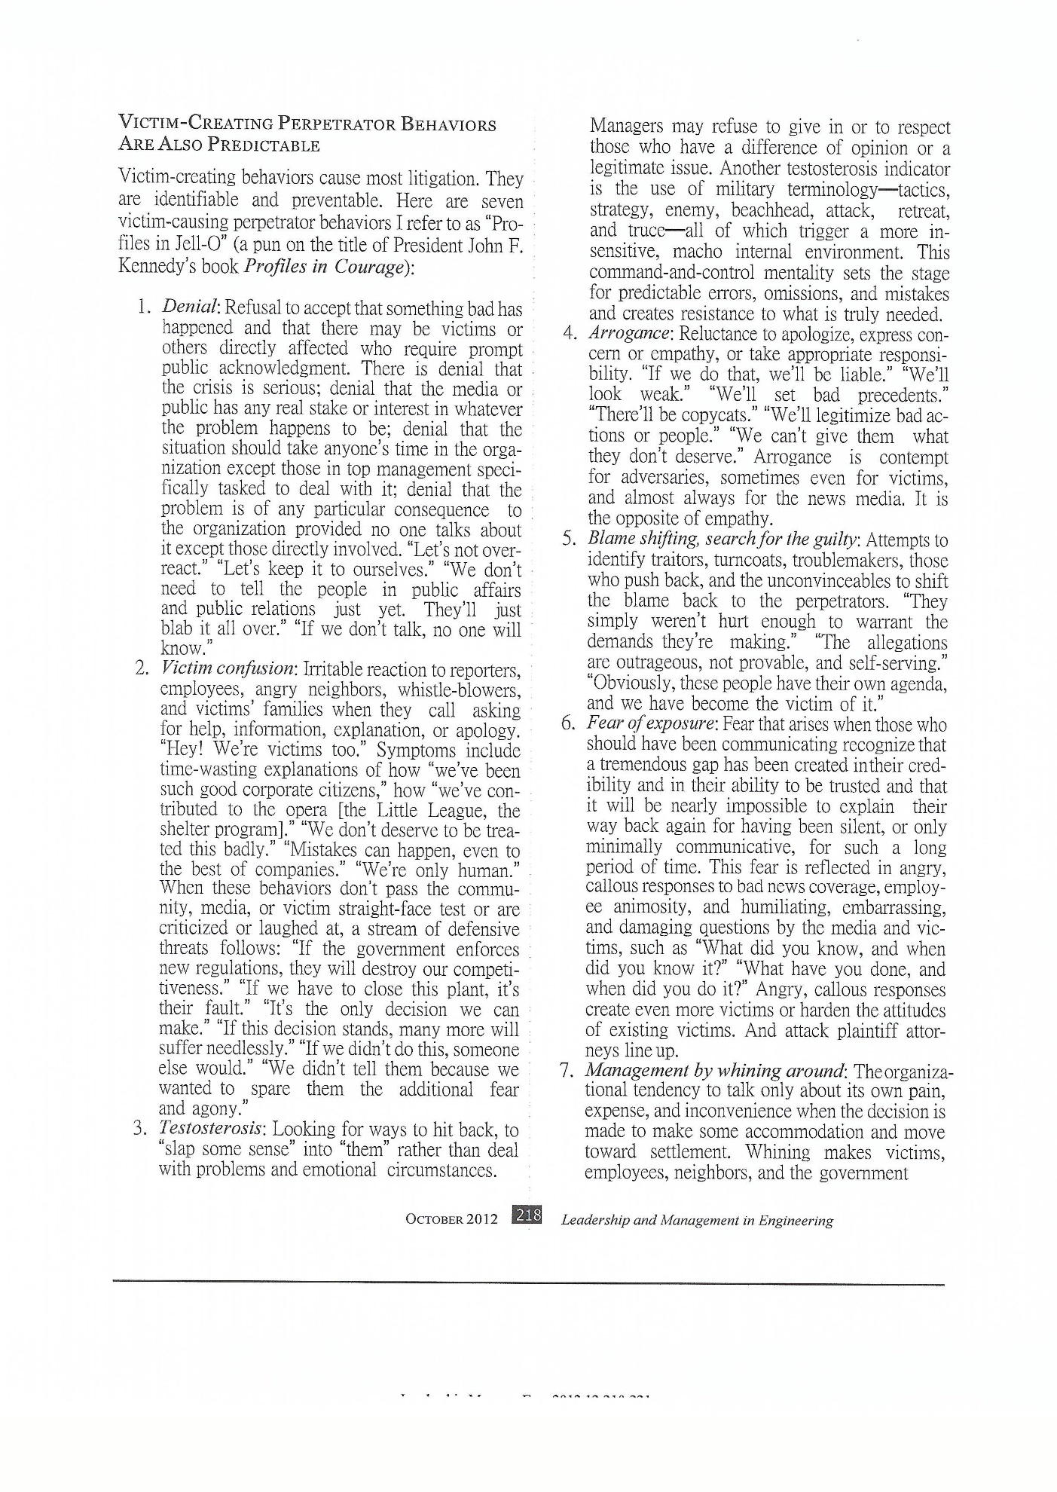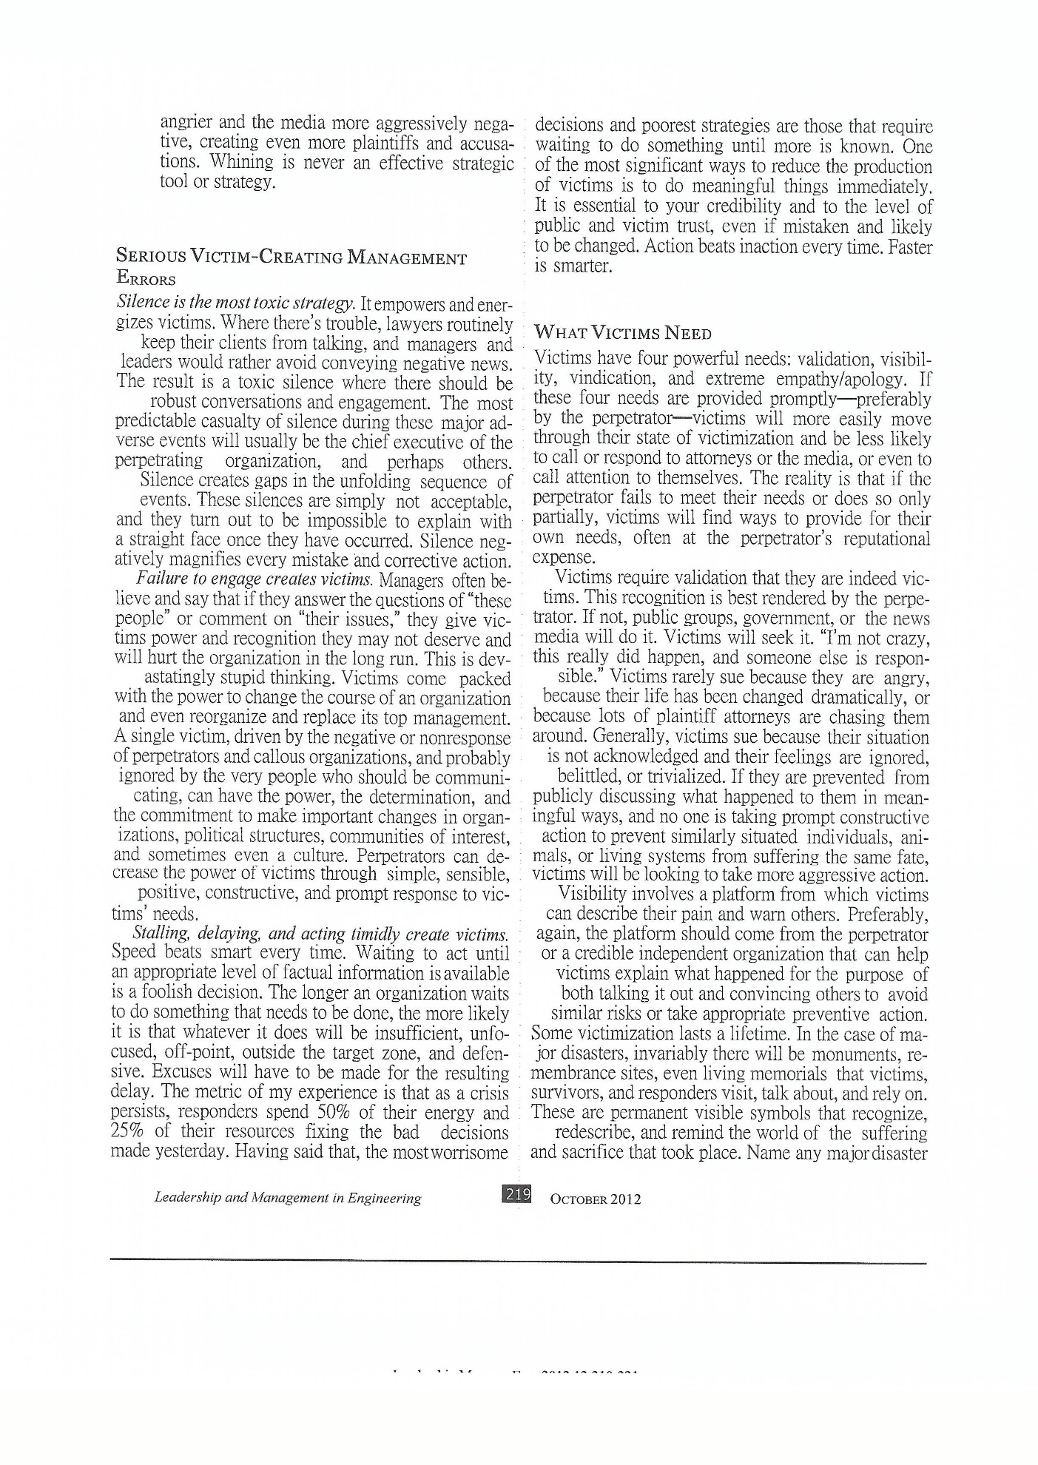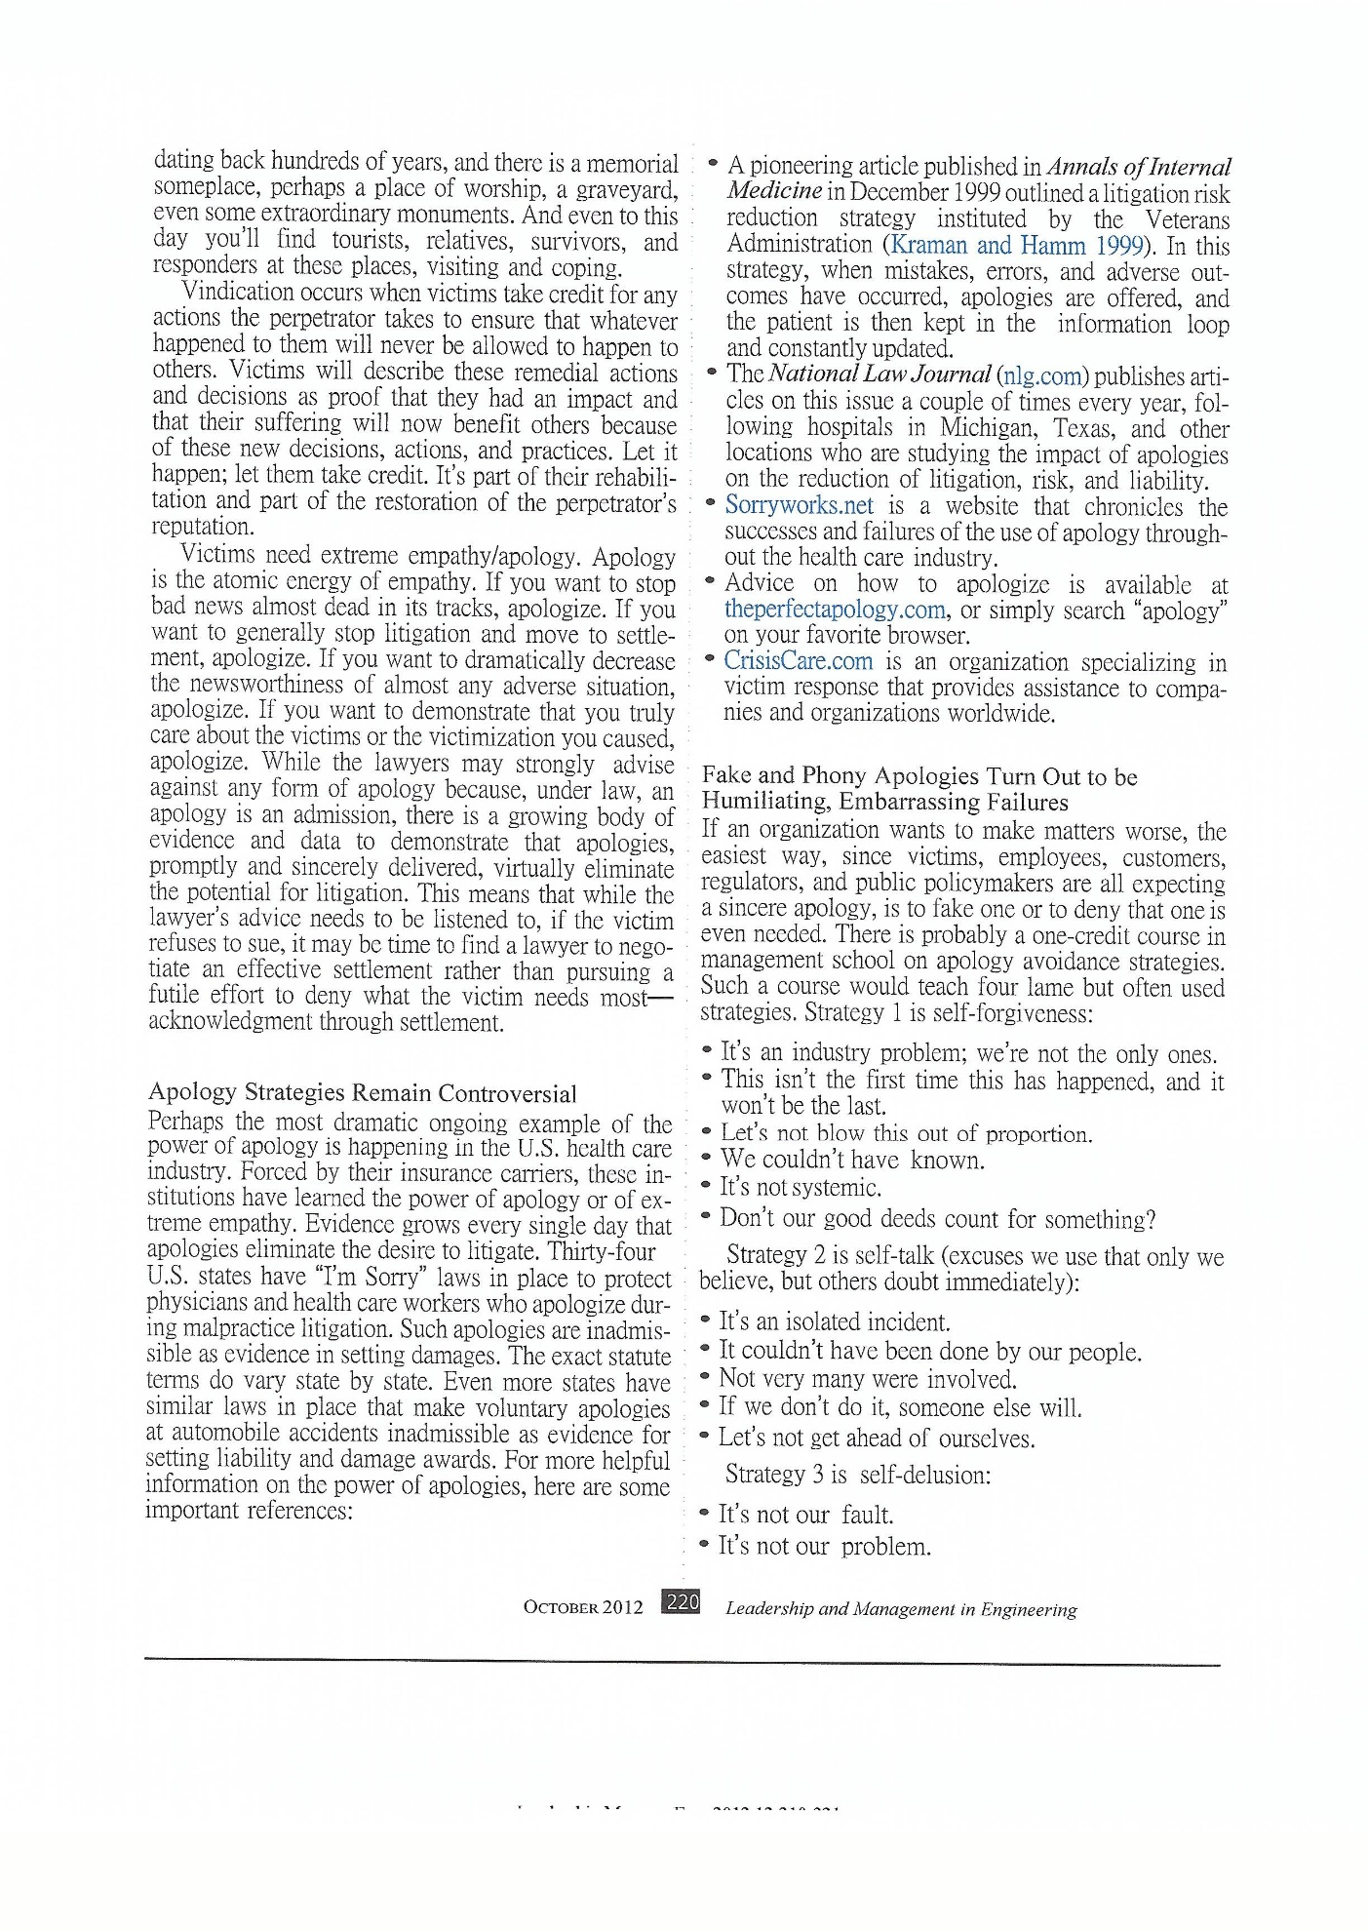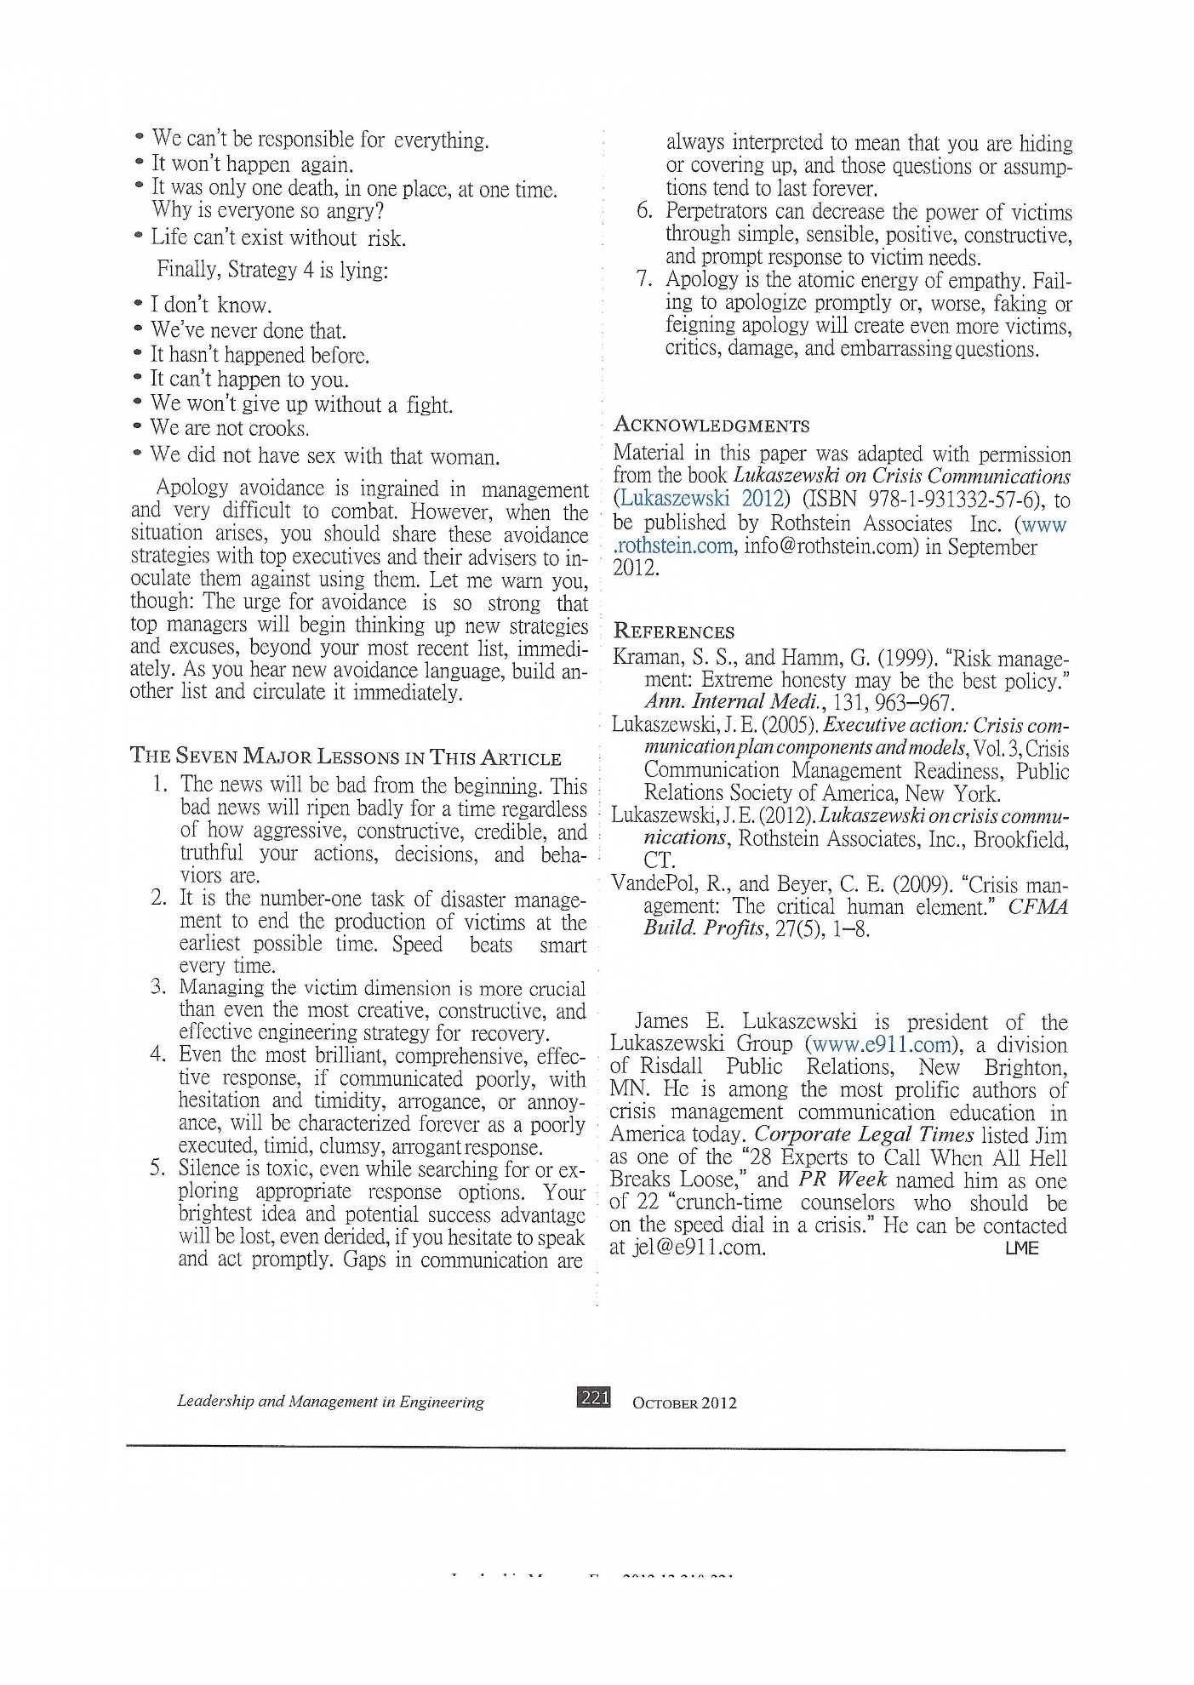

Based on an article published in PR News Tipsheet

The Perfect Apology
The atomic energy of empathy

By James E. Lukaszewski,
ABC, Fellow IABC, APR, Fellow PRSA, BEPS Emeritus

WO
: 998The most powerful action in reputation recovery and rehabilitation is to apologize. If you want or need forgiveness, you’ll need to apologize. “Wait a minute,” you say, “The lawyers won’t ever let me apologize.” Well, let’s talk about apology, understand it, and then we’ll get back to the attorneys.
Management avoids apologizing by using an amazing array of avoidance strategies. There’s self-forgiveness: “It’s an industry problem, we’re not the only ones,” “Let’s not blow this out of proportion.” There’s self-talk: “It’s only an isolated incident,” “It’s never happened before,” “Not very many were involved,” “Let’s not get ahead of ourselves,” “If we didn’t do it, someone else would.”
Look for self-delusion: “It’s not our fault,” “It’s not our problem,” “We can’t be responsible for everything,” “It won’t happen again,” and “Life can’t exist without risk.” Or how about lying: “I don’t know,” “We’ve never done that,” “It won’t ever happen again,” “I am not a crook,” and “I did not have sex with that woman.”
Look for self-immolation: “you don’t need to see all the information we have,” “much of the information is protected from public view by statute,” “we can’t be more explicit because we’ll damage the reputation of innocent bystanders,” “it’s a secret,” “if we were to tell you it would jeopardize or reveal other important information,” “this could contaminate other legal proceedings.” Balderdash, nonsense, gibberish, claptrap, blather, hogwash, drivel, bunk, piffle, and more than a dozen more pejorative adjectives you’ll find on dictionary.com.
At the present moment apology is really out of fashion. We are seeing a trend towards doubling down on mistakes, uncivil behavior, and evermore strategies describing apology as weak, even cowardly behavior.

The fact remains that apologies, when genuinely delivered, really are the atomic energy of empathy. They tend to stop bad things from starting.
The perfect apology has three components: First and foremost, the perpetrator has to have an attitude of humility; then an apology strategy, which leads to sincerity of action. Here are the elements of an apology strategy:

- Ongoing expressions of regret and empathy
- Continuous explanation of how behavior will change
- If serious enough, third party oversight of new behaviors, reported independently, can allay public and victim concerns
- Encouragement of public discussion, especially by the victims about the perpetrator’s mistakes and callousness
- Commitment to overcompensate and complete restoration of damages and injury
- Resolve to maintain contact with the victims and survivors until they lose interest

One of the most constructive structures for apology I’ve seen is in The Five Languages of Apology, a book by Gary Chapman and Jennifer Thomas. Here, with some paraphrasing and modification based on my experiences, are the ingredients of the perfect apology.

- Regret (acknowledgment) − A verbal acknowledgement by the perpetrator that their wrongful behavior caused unnecessary pain, suffering, and hurt that identifies, specifically, what action or behavior is responsible for the pain.

- Accepting Responsibility (declaration) − An unconditional declarative statement by the perpetrator recognizing their specific wrongful behavior and acknowledging that there is no excuse for the behavior.

- Restitution (penance) − An offer of help or assistance to victims, by the perpetrator; action beyond the words “I’m sorry”; and conduct that assumes the responsibility to make the situation right.

- Repentance (humility) − Language by the perpetrator acknowledging that this behavior caused pain and suffering for which he/she is genuinely sorry; language by the perpetrator recognizing that serious, unnecessary harm and emotional damage was caused and that their behavior will change to avoid future offense.

- Direct Forgiveness Request − “I was wrong, I hurt you, and I ask you to forgive me.”

The most difficult and challenging aspects of apologizing are the admission of having done something hurtful, damaging, or wrong, and to request forgiveness. Skip even one step and you fail.
Do apologies matter? “In an effort to reduce medical liability/malpractice lawsuits and litigation expenses, state legislators and policymakers are changing the laws to exclude expressions of sympathy, condolences or apologies from being used against medical professionals in court. Proponents of these so called “I’m sorry” court laws believe that allowing medical professionals to provide these statements can reduce medical liability/malpractice litigation.”
“Thirty-nine states, the District of Columbia and Guam have provisions regarding medical professionals making apologetic or sympathetic gestures. Of these states, six states have provisions that specifically relate to accidents. Those states are California, Florida, Massachusetts, Tennessee, Texas, and Washington (Source: National Conference of State Legislatures).
The biggest problem with apology is the attitude among leaders and their attorneys that apology is “sissy” stuff. My advice is, “Get over it.” There’s mounting statistical evidence in health care that apologies, even if they are required by insurance companies (which they more frequently are), are having a dramatic affect on reducing litigation.
So now we’re back to attorneys. When the lawyers say you can’t apologize because it’s an admission of something (which it is), you can tell them (with nearly absolute certainty) that an apology will, at a minimum, mitigate and, at a maximum, eliminate litigation. An apology may be the trigger to settlement. Failure to apologize is always a trigger for litigation.
Today’s legal reality is that only a tiny number of civil and criminal cases filed ever get to trial. Instead, these cases will be settled, dismissed, or resolved by some other mechanism such as arbitration. Empathy is where “actions speak louder than words.” Apology is the atomic energy of empathy because failure to apologize is an integrity lapse that causes the corrosive destruction of your reputation, and creates an impression of you as arrogant and callous.
The lesson for leaders is that while it’s true apologies can have legal consequences, the act of apologizing is a uniquely leadership decision. Most important leadership decisions and actions have legal consequences, but the evidence increasingly shows that apology’s beneficial impacts far outvalue the legal risks. Apology is among the most powerful acts of leaders and leadership.

Winning When Everybody is Mad at You

These seven statements give an indication of my philosophy and strategic approach for winning:
1. Wage peace everyday. Do something else when you will have war for sure. War produces casualties and victims all of whom work to live long enough to destroy your best efforts. Reduce the production of critics at every opportunity.
2. Contention is the absence of agreement. Work for agreement, incrementally, everyday.
3. Getting permission depends upon gaining public agreement and consent. Avoid all resist anything, anyone, or any decision, that delays, denies, disables, or damages the permission process.
4. Control testosterosis. Anger, irritation, frustration, confrontation cloud judgment, damage relationships, cause misunderstandings, and rarely accomplish anything good.
5. Recognize and leverage from the patterns of democracy, avoid political games and game players, all those people have different agendas from yours.
6. Work as directly as you can. Like most everything that matters in life, agreement is generally achieved, when the principals relentlessly commit to sit down face-to-face and directly work it out..
7. Success depends on communication, common sense, direct, prompt action, empathy, transparency and engagement. Explain to everyone as well as remind them of your communication and behavior intentions so they will know how to behave in return.
Here is a here is a brief portion of our experience relevant to this project:
TLG work with clients under attack (or where a significant risk exists) in communities for corporate clients:
1. Siting a non-toxic, nonhazardous landfill for a paper mill in the east central US be successful would mean the loss of 2500 jobs at the plant worth about $1 billion. The issue came down to a zoning variance process, a public, corporate election on the issue and eight years of litigation. Highly flammable state EPA engagement and confusion, some of us lead to our success.
2. Siting a 900 acre limestone quarry (proposed depth 250 feet) in a small town, in the Midwest. Up to the point of this product was proposed this little town had only farmers with cows and corn. This one would have been lost had the time trustees not made a couple mistakes and angered the judge. It also helped that after three years of intensive, corrosive opposition by a single person, that individual's moving away provided the opportunity for negotiations and significant progress.

YOUR QUICK GUIDE TO THE CRISIS COMMUNICATION
MANAGEMENT PLANNING PROCESS:
A MODEL MANAGEMENT PRESENTATION OUTLINE ©

James E. Lukaszewski, ABC, Fellow IABC, APR, Fellow PRSA, BEPS Emeritus
Roseville, MN, U.S.A.

Published by The Lukaszewski Group 8306 Norman Creek Trail, Bloomington, MN 55437.
Copyright © 2018, James E. Lukaszewski. All rights reserved. ISBN 978-1-883291-71-6

INTRODUCTION
Effective crisis response plans tend to fulfill five powerful objectives. They: produce decisions that reflect fundamentally sound thinking and behavior; manage the first few minutes, few hours of a crisis; reduce media coverage and public interest is reduced from the start; involve management meaningfully in the process of crisis planning, management, response and recovery; and work against the known patterns of mistakes and problems management tends to cause themselves when crises occur.

Effective planning answers many crucial questions. These are among the most important:

- Has the boss approved/participated?  - Has the entire process been tested?  - How do we know we’ve won or lost?  - How do you assess collateral damage?  - What are the messages going to be?  - What do we do first?  - What if the boss refuses to participate?  - What will the victims do? | - What will the victims say?  - What’s the plan?  - When do we put the boss out front?  - When does it stop being a crisis?  - Who says it’s a crisis?  - Who’s in charge?  - Who’s on the back-up team?

Crisis communication management planning (now much more commonly referred to as readiness planning) is a process with identifiable steps, elements, parts, and phases. To increase management buy-in, organizational acceptance, and a fundamental understanding of what needs to be accomplished as you design a crisis communication management response process, it’s helpful to touch on a predictable but reasonably complete checklist of bases. Begin with your definition of crisis. Following that, using this checklist, develop language of your own to explain each of these relatively obvious action steps or decision points.

BEFORE YOU BEGIN

Crisis Defined

What’s needed first is an appropriate and understandable working definition of crisis. Here is mine:

Crises are show-stopping, people-stopping, product-stopping, reputation-defining situations that create victims and/or explosive visibility. Anything less falls more into the category of a problem or issue that, while disruptive, has far less potential to create explosive, unplanned visibility.
Readiness
Use the term “readiness” because it more accurately reflects what crisis preparation is all about. It’s a more management-oriented term, and has really become a key response concept since the attack on the United States in September 2001. Using this approach begins to raise a better question, “How ready are we to deal with the most serious problems we expect to face?”
The heart and soul of a successful crisis response is a process that can be activated immediately and continues building until the situation either reaches some level of control or the momentum of the crisis has abated. Then, established corporate functions can be imposed and resumption, as well as business activity recovery, can take place. Practically speaking, crisis planning takes months, while execution of the crisis response must take place in only a few minutes to a few hours.
The faster you can capably respond in meaningful ways, the sooner both the crisis and victim generation subside. The organization can then begin to return to some semblance of normalcy.

The Readiness Equation

Accurate contact information |  | 75%
Pre-authorization |  | 15%
Extensive scenario preparation and testing |  | 8%
Surprise |  | 2%
 | 100%

The Crisis Communication Plan Development Process
There are eight clear-cut and direct steps in the crisis plan development process:
- Visibility analysis
- Prioritize exposures, i.e., likelihood, impact, and probable collateral damage
- Scenario development
- Message development
- Crucial contact list development
- Emergency media relations instructions
- Installation, testing, drills, table tops
- Continuous updating and internal education

CRISIS COMMUNICATION
MANAGEMENT RESPONSE PLAN COMPONENTS
Crisis Venues
The nature of crisis can be better understood if we recognize the venues in which crisis is likely to occur and the types of crises that may be expected, recognizing that often there are combinations.
The seven venues of crisis are:
- Headquarters
- Top management
- Local
- Regional
- National
- Global
- Virtual

The six types of crisis are:
- Operating, i.e., directly involving how the business works everyday

- Non-operating:
- Berserk employee  - Bomb threats  - Business loss  - Congressional action  - Crimes in progress  - Criminal behavior  - Decapitation  - Demonstrations / protests  - Disgruntled employee  - Major theft | - Embezzlement  - Employee violence  - Ethics problems  - Extortion  - Kidnapping  - Litigation  - Major allegations  - Major business decisions  - Major crime | - Obscene / coercive telephone calls  - Sabotage  - Scandal  - Sexual harassment  - Stock price drop  - Terrorist actions  - Web attacks  - Whistleblowers  - Workplace violence

- Combinations of the two, or more

- Disasters:
- Earthquake  - Evacuation  - Explosion  - Fire / flames  - Flooding / torrential rain  - General disruptions / threats  - Hazardous materials / chemical spills / gas leaks / toxic fumes  - Major storms | - Medical emergencies  - News media response  - Noxious odors  - Power outages  - Ruptured water pipes  - Smoke / burning odors  - Tornado  - Winter storms

- Insidious unethical behaviors

Besides the more obvious mistakes that lead to unethical behaviors, there are other, less apparent, more insidious kinds of unethical behaviors that can lead to problems.

Sometimes these less obvious behaviors are the precursors to illegal behavior. When you can identify these behaviors in your vicinity, there is trouble ahead. Act promptly to correctly these situations.

- Lax control: A manager’s careless enforcement, education about, and monitoring of ethical standards.
- Lack of tough, appropriate centralized compliance within each area of the company.
- No one charged with responsibility of teaching, enforcing, and disciplining in cases where ethical breaches occur.
- Leadership that allows supervisors to overlook bad behavior.
- Leadership that allows employees to experiment with methods and tactics outside established guidelines.
- Emphasis on “doing whatever it takes” to achieve appropriate business and financial goals.
- Managers and supervisors who minimize the importance of oversight and compliance processes.
- Structuring incentives in such a way that they can compromise the ethical behavior of people, the quality of the products and services we deliver, and allow shortcuts to be taken for a variety of obviously questionable reasons.
- Avoiding confrontation with managers who chronically misbehave or chronically overlook misbehavior.
- The tendency to operate “on the edge,” always pushing for more than is appropriate.
- Management that ignores the signs of and doesn’t question rogue behavior.
- Management tolerating the inappropriate behavior or management by individuals who are “critical to the organization’s mission.” These are the folks who are the super sales people, the high achievers who are allowed to break the rules to maintain the altitude of their performance.
- Belittling or humiliating those who suggest or seek ethical standards.
- Dismissing or destroying the careers of employees who report bad or outright wrong behavior.
- Demeaning the internal or external credibility of those who blow the whistle, those who report or bring management’s attention to lapses in ethics.

- Virtual:
- Anti-corporate activism
- Anti-corporate blogs
- Boycotts
- Bullying
- Imposter sites
- Personal attacks
- Pornography links
- Rumors
- Short selling
- Web attacks/Web sites

RESPONSE PRIORITIES: THE GRAND STRATEGY

- Stop the Production of Victims Page 6
- Manage the Victim Dimension Page 6-7
- Employee Communication Page 8
- Contact Those Indirectly Affected Page 8
- Deal with the Self-Appointed, Self-Anointed, and the Media Page 8

- Stop the Production of Victims

Stop the production of victims. Resolve the problem promptly; begin addressing key issues. If it’s leaking, foaming, smoking, burning, creating victims, deal with the underlying problem first.

- Manage the Victim Dimension

It is victims and others who are directly affected that cause incidents to become crises. Be prepared to understand the dynamics of victims and anticipate those dynamics as the response process proceeds.
Victims Are:
  - People
  - Animals
  - Living systems

Victimization Is:
- Self-designating
- Self-maintaining
- Self-terminating

Victimization Is Caused by:
- Abuse  - Arrogance  - Bullying  - Blame shifting  - Callousness  - Carelessness | - Commission  - Confrontation  - Deception  - Denial  - Discrediting  - Dismissiveness | - Disparagement  - Embarrassment  - Fear  - Ignorance  - Insensitivity  - Lies | - Minimization  - Negligence  - Omission  - Sarcasm  - Shame  - Surprise
Victims Feel:
- Anger
- Betrayal, disbelief, dread, and fear
- Frustration
- Powerlessness, helplessness
- Inadequate
- Walking but wounded, agonized, alone

Victims Suffer:
- Intellectual deafness
- 24/7 internal and external monologue
- Everything is a question

Victims Need:
- Validation
- Preferably by the perpetrator

Visibility
- To describe their pain and warn others
- Vindication
- Resolution that prevents the victimization of others
- Apology
- The single most powerful litigation stopping act
- Employee Communications

Every employee is a communicator when something happens. Whether there are 10 employees or 10,000 employees, when questionable activity or crisis occurs, everyone affected becomes a communicator. Inform, educate, and script employees promptly. Non-communication is a toxic strategy.

- Contact Those Indirectly Affected
(neighbors, regulators, governments, friends, allies, families, relatives)
Every crisis causes damage, injury, or fear in a large number of individuals who are indirectly affected: your Agency infringes on another Agency or your problems taint your relationship with an ally, allied organization or interest group. Inform them.

- Deal With the Self-Appointed, Self-Anointed, and the Media

Almost every crisis brings out individuals and organizations with their own agendas. Your crisis presents the opportunity to activate those agendas. Then there is the news media that can bring substantial attention to your crisis and you, usually focusing on or speculating about what went wrong, who’s responsible, who the victims are, how bad it could possibly be. . . and even worse.

THE GOLDEN HOUR

The key concept to remember here is that each of these five steps must be activated in the first hour, or first two hours, of any crisis. Failure to activate all of these priorities will cause additional victims, questions, misunderstandings, and collateral damage, which the perpetrator will have to deal with as the crisis is resolved.

The Golden Hour Metaphor

The first hour or two of crisis situations are often referred to as the Golden Hour or hours. The phrase comes from military medicine at the close of World War II, and during the Korean conflict. Military medical studies indicated that the single most prevalent cause of death for wounded soldiers was blood loss, the failure to get these individuals into serious life-saving medical treatment quickly after being wounded. They were bleeding to death in the Jeeps driving them to the hospitals located in rear areas of the battlefield.

The helicopter, which was brought into ever wider military use following World War II, was the perfect vehicle to get wounded soldiers quickly off the battlefield. But one more critical component was needed. Surgical facilities had to be as close as possible to the battle lines to reduce even further the risks and damage associated with transporting the wounded to urgent care.

The U.S. Army came up with the mobile hospital concept, the” Mobile Army Surgical Hospital,” or MASH as they became widely known, just like the television show. These mobile facilities were located right on the battle line and moved with the progress of the battle.

Here’s the point, 96% of wounded soldiers who arrived alive at a MASH, regardless of the severity of their injuries, left the MASH alive.

To me, this is the perfect metaphor when combined with following the Grand Crisis Response Strategy to address what management has to be ready to accomplish in those first 60 to 120 dangerous, frightening and chaotic minutes of a crisis.

PROFILES IN FAILURE
Sometimes the only way to help organizations avoid embarrassment, humiliating visibility, enormous litigation, and just plain stupidity is to illustrate dramatically the pattern of behaviors and attitudes that lead to catastrophic reputational trouble. I call this pattern “Profiles in Failure.” These behaviors can be easily recognized and their impact predicted. If you are looking for trouble, here’s the way to quickly multitask your way into long-term difficulty.

- Silence: | The most toxic strategy possible. Makes you look like a perpetrator, whether true or not. There is no credible way to explain silence in the face of crisis. Silence is the most frequent career-killer in crisis situations.
- Stalling: | Speed beats smart every time. Failure to act immediately, even incorrectly, is impossible to explain or apologize for. Doing nothing, even for what appear to be good reasons, is never explainable.
- Denial: | Refuse to accept the fact that something bad has happened and that there may be victims or other direct effects that require prompt public acknowledgement.
- Victim Confusion: | Irritable reaction to reporters, angry neighbors, and victims’ families when they call asking for help, information, explanation, or apology. “Hey! We’re victims too.”
- Testosterosis: | Look for ways to hit back, rather than to deal with the problem. Refuse to give in, refuse to respect those who may have a difference of opinion or a legitimate issue.
- Arrogance: | Reluctance to apologize, express concern or empathy, or to take appropriate responsibility because, “If we do that, we’ll be liable,” or, “We’ll look like sissies,” or, “We’ll set a precedent,” or, “There will be copycats.”
- Search for the Guilty: | Shift blame anywhere you can while digging into the organization, looking for traitors, turncoats, troublemakers, those who push back, and the unconvinceables.
- Fear of the Media: | As it becomes more clear that the problem is at least partly real, the media begin asking, “What did you know, and when did you know it?”, “What have you done, and when did you do it?”, and other humiliating, embarrassing, and damaging questions for which there are no really good, truthful answers anymore because you have stalled so long.
- Whining: | Head down, finger in your navel, shuffling around, whining, and complaining about how bad your luck is, about being a victim of the media, zealous do-gooders, wacko-activists, or people don’t know anything; about how people you don’t respect have power; and, that you “don’t get credit” for whatever good you’ve already contributed.

Execute one, some or all of these behaviors in any order and I guarantee trouble, serious reputation problems, and brand damage. By the time you recover − if you do − look for some career-defining moments including involuntary departure, and a new team may replace you and yours.

RELATED INFORMATION
TO HELP YOUR PLAN SUCCEED
Key Ingredients in a Successful Planning Process
To avoid response failure, certain key ingredients must become part of the crisis communication planning process:
- Top management buy-in
- Specific rules for leaders
- Strategies by scenario
- Activation procedures (see triggers above)
  - Corporate management team
  - Senior management response team
  - Special response unit
  - Crisis czar
  - Incident command
  - Call center
- Call Headquarters If, process
- Corporate level buy-in
- Division / branch / field buy-in
- Follow up and updating procedures
- Installation, testing, and effectiveness programs
- Web site readiness

Key Roles for Leadership
What the Boss Should Really Do in a Crisis

One of the more powerful weaknesses in crisis response is the lack of specific roles and assignments for top management. The result of this crucial gap in crisis management planning is the mismanagement, lack of management, or paralysis that afflicts crisis response efforts. This defect occurs all too frequently in plans I review, responses I analyze, and scenarios I explore with client companies.

In the course of directing a client’s crisis developing powerful response strategies, it’s clear to me that crisis response promptness and effectiveness depends on having five essential responsibilities spelled out carefully in your crisis plans for the CEO (or surviving leaders): response, analyzing past responses to crisis, or

- Assert the moral authority expected of ethical leadership. No matter how devastating or catastrophic the crisis is, in most cultures forgiveness is possible provided the organization, through its early behaviors and leadership, takes appropriate and expected steps to learn from and deal with the issues. The behaviors, briefly and in order, are:
  - Candor and disclosure (acknowledgement that something adverse has happened or is happening)
  - Explanation and revelation about the nature of the problem (some early analysis)
  - Commitment to communicate throughout the process (even if there are lots of critics)
  - Empathy (intentional acts of helpfulness, kindness, and compassion)
  - Oversight (inviting outsiders, even victims, to look over your shoulders)
  - Commitment to zero (finding ways to prevent similar events from occurring again)
  - Restitution or penance (paying the price – generally doing more than would be expected, asked for, or required)

- Take responsibility for the care of victims. The single most crucial element in any crisis, aside from ending the victim-causing event, is managing the victim dimension. There are only three kinds of victims: people, animals, and living systems. It’s top management’s responsibility to see that appropriate steps are taken to care for victims’ needs. This is both a reputation preservation and a litigation reduction activity. Most devastating responses to crises occur when victims are left to their own devices, when victims’ needs go unfulfilled, or for whatever reasons (usually legal) the organization that created the victims refuses to take even the simplest of humane steps to ease the pain, suffering, and victimization of those afflicted. Out of all of the CEO’s essential responsibilities, taking a personal interest and an active role in the care of victims is the most important. Maintain a positive, constructive pressure to get victim issues resolved promptly.

- Set the appropriate tone for the organizational response. Tone refers to internal management behavior that helps the organization meet the expectations triggered by a crucial, critical, or catastrophic situation. If senior management takes on the posture of being attacked or victimized, the entire organization will react in the same way. Very rarely are large organizations and institutions considered victims. They’re generally considered to be the perpetrators at worst, or arrogant bystanders at best.

It’s the most senior executives who need to set a constructive tone that encourages positive attitudes, language, and prompt responses. This approach protects the organization’s relationships with various constituents during the response and recovery period, shows respect for victims, and reduces the threat of trust or reputation damage.

- Set the organization’s voice. Put a face and a voice on the organization or institution as it moves through the crisis. This action is directed towards the external world – how we describe ourselves, what we’re doing, how the response is going, what responsibilities we’re taking, and what outside scrutiny we’re inviting.

- Commit acts of leadership at every level. Leaders acting like leaders has significance during urgent situations. Literally walk around and talk to people. Encourage, suggest, knock down barriers, and help everyone stay focused on the ultimate response process goals. Random acts of leadership are always welcome in any environment, but especially during crisis. Rather than huddling in their executive offices trying to determine what steps should be taken to resolve the situation, ninety percent of senior executive activities should have executives out-and-about being leaders, motivators, and instigators of empathy.

Of all of these, it’s the prevention of similar occurrences that will help victims come to closure and provide sufficient evidence that enough lessons have been learned to avoid the need for litigation and other forms of public embarrassment and humiliation.

All crises are management problems first. Preplanning executive actions can avoid career-defining moments. Include specific executive instructions in all plans and response scenarios.

Typical Organization Barriers
An audit of potential organizational or process disruptions needs to be completed early in the process. Look for:
- Resistance to automatically trigger corporate notification, i.e., a Call Headquarters If list
- Competing response priorities between divisions, functions, and product lines
- Other existing plans, e.g., plans developed by others or required by government regulations
- Relationship between corporate and division/branch/field operations
- Response confusion and turf issues
- Existing management response plans
READINESS PLANNING CYCLE

Readiness preparation and planning processes to manage crisis communication can each be divided into important subcategories.
- Preemption:
- Codes of conduct
- Compliance
- Integrity

- Preparation:
- Business resumption
- Dark sites:
- Typical Web content:
- Advertising  - Applications and filings  - Comparisons with other sites  - Contrast analysis  - Corrections and clarifications | - Dear So and So  - In the news  - Issues and policies index  - Letters  - Links  - News and views | - Our purpose  - Overview  - Presentations  - Publications  - Q&A  - Who we are
- Disaster recovery
- Crisis communication
- Incident response triggers
- Senior management team  - Corporate management team  - Crisis czar | - Special response unit  - Incident command  - Call centers

- Planning:
- Corporate
- Leadership team
- Division / branch / field
- International or non-domestic
- Combinations of the above
- Web

- Response:
- Corporate leadership
- Corporate headquarters
- Brach / division / field
- International
- Virtual

- Recovery:
- Scenario driven
- Collateral damage assessment and remediation
SCENARIO DEVELOPMENT WORKSHEET

Instructions for Use:
Use this form to sketch out brief scenarios that are “quick take” analyses of specific key issues or critical situations/events your organization might face. These scenarios are basic thinking and analytical tools in the development of a more detailed flowchart of events, which will depict the major events, steps, and decision points leading to the resolution of your key issue.

KEY ISSUE

SITUATION

Briefly describe the nature of the issue, problem, or situation.

ANALYSIS

Briefly describe what the situation means, what its implications are, and how it threatens your organization.

OPTIONS
Develop at least three response options for the situation you’ve presented. You could suggest more, but three is optimal for management to choose from.

RECOMMENDATIONS

This is what you would do if you were in your boss’ shoes and why.
UNINTENDED CONSEQUENCES

List here those events or problems that could arise due to the options you’ve suggested or by doing nothing.

EXAMPLE SCENARIO DEVELOPMENT WORKSHEET
KEY ISSUE |  | Drug raid on a branch plant
SITUATION  Briefly describe the nature of the issue, problem, or situation. |  | - Feds and state authorities raided the second shift.  - Twenty-six employees were taken into custody.  - Media were tipped and went in with police.  - Story is all over the television and radio.  - Employees believe that we knew about the drug problem, but didn’t do anything about it.
ANALYSIS  Briefly describe what the situation means, what its implications are, and how it threatens your organization. |  | - We looked like we were afraid or reluctant to act.  - Everyone who worked there seemed to know more about the situation than we did.  - Drugs are manufactured in an old part of the plant.  - There may be some who weren’t caught (ringleaders).  - There’s fear among employees that it’s not over.
OPTIONS  Develop at least three response options for the situation you’ve presented. You could suggest more, but three is optimal for management to choose from. |  | - Reveal that we worked with cops to set up raid.  - Provide counseling for innocent employees.  - Try to save those who are victims.  - Make sure ringleaders get punished.  - Let the cops handle it.
RECOMMENDATIONS  This is what you would do if you were in your boss’ shoes and why. |  | - Work to reduce tension in the facility.  - Keep police collaboration confidential since we need to catch everyone.  - Establish employee committee to set rules to prevent future occurrences.
UNINTENDED CONSEQUENCES  List here those events or problems that could arise due to the options you’ve suggested or by doing nothing. |  | - Get more bad press.  - Good employees leave.  - Become known as a “gang” place.  - Lose customers.

EXAMPLE SCENARIO DEVELOPMENT WORKSHEET
KEY ISSUE |  | Employee violence
SITUATION  Briefly describe the nature of the issue, problem, or situation. |  | - Former co-worker got past security with a gun.  - Former employee shoots former girlfriend in the lunchroom.  - Former employee holds other employees hostage.
ANALYSIS  Briefly describe what the situation means, what its implications are, and how it threatens your organization. |  | - Employees are rattled.  - Police have taken over scene.  - News reporters call all over the place.  - We are all paralyzed.  - People don’t know what to do or where to go.
OPTIONS  Develop at least three response options for the situation you’ve presented. You could suggest more, but three is optimal for management to choose from. |  | - Let police handle most of it (it is a crime scene).  - Focus on employee shock and discomfort.  - Help families of the afflicted, as well as those who are bystanders.  - Find a way to assess impact on co-workers.  - Find a way to assess impact on company.
RECOMMENDATIONS  This is what you would do if you were in your boss’ shoes and why. |  | - One, two, and three . . . and try to bring in counselors to help people by talking through what they’ve experienced and what they feel.  - There must be an empathetic, positive response by top management to employees to set emotions down.  - Should there be a memorial or remembrance services?
UNINTENDED CONSEQUENCES  List here those events or problems that could arise due to the options you’ve suggested or by doing nothing. |  | - Lack of action could adversely affect employee morale.  - Lack of action could trigger similar events.  - Lack of action sends message that we don’t care.

COMMUNICATING INTENTIONALLY
A trust building platform from which all behaviors, intentions, strategies and decisions flow.

Over the years, I’ve developed, teach, coach and advocate a very powerful and helpful communication philosophy. At the same time, this approach defines my ethical approach to life, to work and to trouble. I call these “intentions” because this is how I seek to operate my life every day, and to teach others to do the same. These behaviors build trust

- Candor – Truth with an attitude, delivered now (the foundation blocks of trust).
- Disclose, announce early.
- Explain reasoning and reasons.
- Discuss options, alternatives considered.
- Provide unsolicited helpful information.

- Openness, accessibility – Be available for the disasters as well as the ribbon cuttings.
- Be available.
- Be willing to respond.

- Truthfulness – Truth is 15% facts and data, 85% emotion and point-of-reference.
- Point of reference matters more than facts.
- Factual overload victimizes people and makes them feel stupid, therefore angrier.
- Unconditional honesty, from the start.
- Get good at handling emotional situations, subjects and people

- Empathy – Action always speaks louder than words.
- Action illustrates concern, sensitivity, and compassion.
- Act as though it was happening to you or someone you care about.
- It is literally impossible to put yourself in someone else’s shoes in any meaningful way, from the victim’s perspective.

- Responsiveness – Answering questions relentlessly in every situation validates your integrity.

- Every concern or question, regardless of the source, is legitimate and must be addressed.
- Answer every question; avoid judging the questioner.
- Avoid taking any question personally.
- Build followers and be nice, even in the face of anger or aggressive negativity. Anger and arrogance create plaintiffs.

- Transparency – No secrets (because important things and stupid stuff always come out.)
- Our behavior, our attitude, our plans, even our strategic discussions are unchallengeable, positive, and explainable.
- Our families would be comfortable reading about our actions, decisions, and discussions on the front page of tomorrow’s newspaper.

- Engagement – Face-to-face is the communications approach desired by just about everyone and every victim.
- Take aggressive positive interaction with those who challenge us.
- Our base and those who give us permission to operate expect us to deal with unconvinceables and victims.
- Prompt direct interactive response, even negotiation, empowers the initiator.

- Destiny Management – It’s your destiny, which only you can manage in your own best interest.
- Manage your own destiny, or you’ll find someone waiting on the sidelines to do it for you.
- Relentlessly correct and clarify the record.
- Prompt, positive, constructive elaboration of the facts preempts critics and empowers employees, supporters and those who give us permission to operate.

- Apology – The atomic energy of empathy. Apologies stop just about everything, including litigation.

- Acknowledge personal responsibility for having injured, insulted, failed, or wronged another.
- Explain what happened and the known reasons for the circumstance.
- Talk about what you and your organization have learned that will help prevent it from ever happening again.
- Humbly ask for forgiveness in exchange for more appropriate future behavior and to make amends.
- Make restitution

You can call this anything you like: communications policy, guidelines or manifesto. I like the word intentions because it signifies that we are fully engaged in communicating in the most effective, honest, empathetic and open manner possible, all the time.
By publically professing these intentions you will set a standard to which you can be held accountable. This behavior can lead to an extraordinarily interesting, useful and trustworthy life
and besides, you sleep better at night.

SEEKING FORGIVENESS:
Nine Steps to Rebuilding and Rehabilitating Trust

Seeking Forgiveness is society’s requirement for relationship, trust, and credibility restoration. Adverse situations using this template are remediated faster cost a lot less, are controversial for much shorter periods of time, suffer less litigation, and help the victims come to closure more quickly. Obtaining forgiveness involves completing the nine steps below. To achieve success in the shortest possible time, these steps should be completed as quickly as possible: like start them all today. Skip a step or be insincere and the process will be incomplete and fundamentally fail.

Step #1 Candor: Outward recognition, through promptly verbalized public acknowledgement, that a problem exists; that people or groups of people, the environment, or the public trust are affected; and that something will be promptly done to remediate the situation.

Step #2 Extreme Empathy/Apology: Verbalized or written statement of personal regret, remorse, and sorrow, acknowledging personal responsibility for having injured, insulted, failed or wronged another, humbly asking for forgiveness in exchange for more appropriate future behavior and to make amends in return.

Step #3 Explanation (no matter how silly, stupid, or embarrassing the problem-causing error was): Promptly and briefly explain why the problem occurred and the known underlying reasons or behaviors that led to the situation (even if we have only partial early information).

Step #4 Affirmation: Talk about what you’ve learned from the situation and how it will influence your future behavior. Unconditionally commit to regularly report additional information until it is all out or until no public interest remains.

Step #5 Declaration: A public commitment and discussion of specific, positive steps to be taken to conclusively address the issues and resolve the situation.

Step #6 Contrition: The continuing verbalization of regret, empathy, sympathy, even embarrassment. Take appropriate responsibility for having allowed the situation to occur in the first place, whether by omission, commission, accident, or negligence.

Step #7 Consultation: Promptly ask for help and counsel from “victims,” government, the community of origin, independent observers, and even from your opponents.
Directly involve and request the participation of those most directly affected to help develop more permanent solutions, more acceptable behaviors, and to design principles and approaches that will preclude similar problems from re-occurring.

Step #8 Commitment: Publicly set your goals at zero. Zero errors, zero defects, zero dumb decisions, and zero problems. Publicly promise that, to the best of your ability, situations like this will be permanently prevented.

Step #9 Restitution: Find a way to quickly pay the price. Make or require restitution. Go beyond community and victim expectations, and what would be required under normal circumstances to remediate the problem.

Implementation, Installation, and Testing

Depending on need, affordability, and practical reality, there are a number of ways crisis communication management plans can be installed and implemented:
- Simulations
- Table-top exercises
- Drills
- Coaching and training
- Updating existing plans

Remember that without competent installation or periodic research or testing, the plan will not work.

Keeping Plans Current

The typical crisis plan has a shelf life of approximately 36 months, even with consistent updating. It’s painfully true that the moment a crisis communication plan is developed and installed, it’s out-of-date in one respect or another. Thus, continuous but reasonable follow-up activities must be undertaken to ensure the validity of the plan, approaches, and the capacity to respond under its guidance when a crisis or emergency occurs. The most helpful are:

- Developing case studies as a vehicle to share critical crisis communication experiences
- Interpreting useful corporate crisis management situations
- Maintaining an active first response team
- Managing corporate exposures and surveillance
- Ongoing indoctrination of managers and supervisors
- Ongoing preparation and training
- Prevention efforts
- Producing right-way/wrong-way videotapes
- Training for new hires

Having compiled this snapshot of the process, it’s time to focus your approach on the process of developing a crisis communication management plan within your organization.

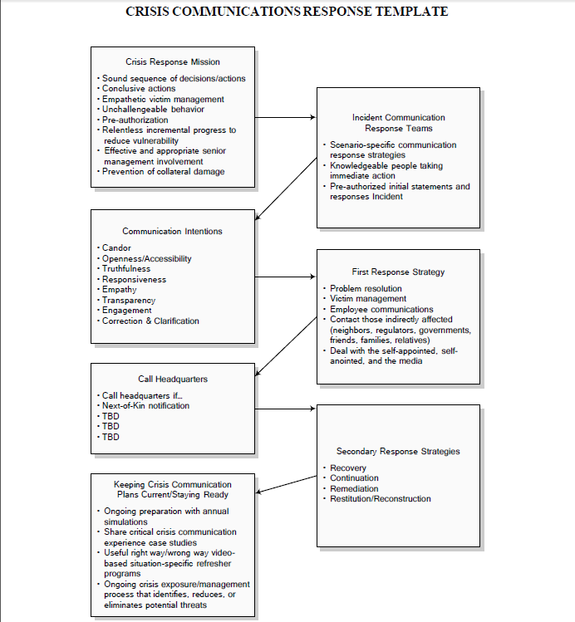

https://www.amazon.com/Decency-Code-Leaders-Building-Integrity/dp/1260455394

The Five Languages of Apology: How to Experience Healing in All Your Relationships, Gary Chapman and Jennifer Thomas. Northfield Publishing, September 1, 2006; ISBN 1881273571.

